**Course Three**

# Go Beyond the Numbers: Translate Data into Insights



# Instructions

Use this PACE strategy document to record decisions and reflections as you work through this end-of-course project. You can use this document as a guide to consider your responses and reflections at different stages of the data analytical process. Additionally, the PACE strategy documents can be used as a resource when working on future projects.

# Course Project Recap

Regardless of which track you have chosen to complete, your goals for this project are:

* Complete the questions in the Course 3 PACE strategy document
* Answer the questions in the Jupyter notebook project file
* Clean your data, perform exploratory data analysis (EDA)
* Create data visualizations
* Create an executive summary to share your results

# Relevant Interview Questions

Completing the end-of-course project will help you respond these types of questions that are often asked during the interview process:

* How would you explain the difference between qualitative and quantitative data sources?
* Describe the difference between structured and unstructured data.
* Why is it important to do exploratory data analysis?
* How would you perform EDA on a given dataset?
* How do you create or alter a visualization based on different audiences?
* How do you avoid bias and ensure accessibility in a data visualization?
* How does data visualization inform your EDA?

**Reference Guide**

This project has six tasks; the visual below identifies how the stages of PACE are incorporated across those tasks.

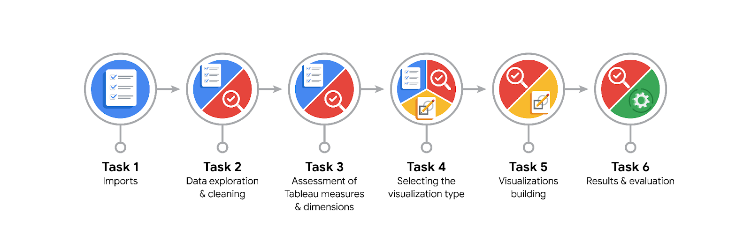

**Data Project Questions & Considerations**

**PACE: Plan Stage**

* What are the data columns and variables and which ones are most relevant to your deliverable?

pd.info() will give you that. As for most relevant, I would say trip duration and total_amount

* What units are your variables in?

Most are numbers either ints or floats, but two are datetime objects. Anything dealing with money is in USD.

* What are your initial presumptions about the data that can inform your EDA, knowing you will need to confirm or deny with your future findings?

I think the rides will be more over the week, maybe Saturday. As for times, I think before and afterwork will be most popular.

* Is there any missing or incomplete data?

No, the data is all there, but pd.isnull() can tell you that

* Are all pieces of this dataset in the same format?

No? As there are some datetime objects, so those will need to be reformated.

* Which EDA practices will be required to begin this project?

**PACE: Analyze Stage**

* What steps need to be taken to perform EDA in the most effective way to achieve the project goal?
* Do you need to add more data using the EDA practice of joining? What type of structuring needs to be done to this dataset, such as filtering, sorting, etc.?

I might make some more data, but that would just be adding columns to the dataframe.

* What initial assumptions do you have about the types of visualizations that might best be suited for the intended audience?

My guess is that a scatterplot will be more successful than others.

**PACE: Construct Stage**

* What data visualizations, machine learning algorithms, or other data outputs will need to be built in order to complete the project goals?
* What processes need to be performed in order to build the necessary data visualizations?
* Which variables are most applicable for the visualizations in this data project?
* Going back to the Plan stage, how do you plan to deal with the missing data (if any)?

******PACE: Execute Stage**

* What key insights emerged from your EDA and visualizations(s)?
* What business and/or organizational recommendations do you propose based on the visualization(s) built?
* Given what you know about the data and the visualizations you were using, what other questions could you research for the team?
* How might you share these visualizations with different audiences?